**Toilets in Australia – Technical Report**

Group 7: Ethan Ericson, Jaxon Ham, Andrew Mendez, Medhansh Sankaran, Ethan Styles

University of Arkansas

DASC 22103 – Data Visualization and Communication

Dr. Davis

12/03/2024

# **Introduction**

Hygiene is immensely important to personal health, and as members of the Australian Department of Health and Aged Care, we should take all possible measures to ensure universal access to basic hygiene facilities that will maintain and improve our population’s health.

The most effective way to provide these facilities to the nation is through the construction and management of public toilets, which our department has spearheaded for decades. As part of this initiative, we performed the following analysis on Australia’s toilets with the goal of determining if our department should relocate, repair, or create new toilets on the basis of traveler access, gender access, disabled access, the spread of disease, and the spread of pollution.

These five areas were determined to be the most important metrics in assessing the effectiveness of our toilet initiative because of their relevance to nearly all of the nation’s health, regardless of demographic identity. Each of the following segments of this paper will be organized by our five areas of analysis: results & recommendations, technical descriptions, and conclusions.

## **Summary**

This report uses data from the National Public Toilet Map of Australia to evaluate the need, or lack thereof, of toilets in the nation based on their availability to travelers, their availability to disabled persons, their availability to gender identities, their impact on the spread of disease in nearby towns, and their impact on the environment through potential pollutants. We found that central Australia has a large need for more toilets with improved accessibility to travelers, disabled persons, and varied gender identities, while the coastal areas are generally well covered by existing facilities.

Furthermore, our analysis showed that the number of toilets is not directly correlated with disease but stipulated that this finding is likely skewed by the high population density of coastal areas, so further research is needed. Finally, the addition of toilets comes with the potential risk of increased air and land pollution, which were shown to be related to the presence of toilets; thus, careful consideration should be given to the location and maintenance of these facilities.

## **Results & Recommendations**

### ***Toilets for Traveling***

Through our analysis, we found that public toilets necessary to cross country travelers are absent or lack many important hygiene amenities such as showers, parking, and dump points within inland Australia. This area of the nation requires more toilets and many upgrades to those facilities’ features to provide basic hygiene to the travelers that use the roads in the region.

### ***Accessible Toilets***

Toilets and other hygiene amenities at facilities accessible to people with disabilities are lacking in central Australia and sometimes in coastal areas. This is an important area of focus, as if even the coastal areas, where resources for accessibility improvements are plentiful, are struggling to provide accessible bathrooms, then there is a true nationwide deficiency in facilities that are available to all types of people. To remedy this problem, attention should be put towards upgrading or adding facilities in urban areas with higher population density first, then expanding focus inward towards the central region of the nation.

### ***Toilets and Public Health***

Our study found that the number of toilets and the presence of certain diseases in nearby towns are not strongly related, but we believe that the large population density of the coastal areas confounds this relationship and overshadows a potential relationship between toilets and health metrics within less dense areas, such as Central Australia. As such, further research is required into this dynamic, and no change to toilets should be made on this metric along before an adequate conclusion has been reached.

### ***Toilets and Pollution***

While water pollution was not found to be strongly connected to the presence of toilets, air and land pollution levels were observed to be tied to toilets. Land pollution was especially affected by toilets, and therefore raises environmental concerns with the addition of toilets to fulfill requirements in the other areas of this study. When toilets are constructed or upgraded, a thorough inspection of waste disposal methods should be performed on site, and then on a continuous basis thereafter to minimize the escape of potential pollutants.

### ***Gendered Toilets***

Unisex toilets are also lacking in the center of the nation, which represents a missed opportunity for more efficient design as well as a failing to meet inclusivity goals. Toilets added in this region should be designed as unisex rather than gendered to increase universal access to hygiene for all gender identities.

# **Technical Descriptions**

## **Toilets for Traveling**

### ***Background/Context:***

This section delves into the availability of public toilets with showers, parking, and dump points along the major roads of Australian. These features of public toilets were chosen because they are necessary to maintain the hygiene of travelers; showers provide this hygiene benefit directly through increased cleanliness, parking ensures that travelers attempting to fulfill their hygiene needs have easy access to the facilities, and dump points enable travelers with toilets in their vehicles to empty their septic tanks regularly to avoid potential contamination from the waste.

### ***Methodology:***

To conduct this analysis, we performed the following actions:

1. Plotted every public toilet on a map of Australia using the Australian toilets dataset
2. Overlayed the major roads of Australia on these points using the Australian major roads dataset.
3. Added a parameter to filter the toilets by the selected amenity (shower, parking, dump point)
4. Calculated the proportion of toilets with the selected amenity, and then investigated where those toilets were distributed within the nation.

### ***Findings/Results:***

We found that the majority of the 24131 toilets in Australia were situated on the coasts, where major urban centers contain high population densities. The Outback, located in the center of Australia, did not have good coverage of its roads with existing public toilets (Figure A1).

Facilities with the amenities of showers and dump points followed a similar pattern of sparseness in inland Australia, making up 7.86% and 5.44% of toilets respectively and being distributed primarily on the coast, leaving large swatches of major roads in the Outback uncovered by basic hygiene facilities (Figure A2 and Figure A4).

Parking, however, is present at 63.94% of toilets, and these toilets, while still less frequent in central Australia than the coasts, do consistently cover the major roads in the area (Figure A3)

### ***Discussion:***

To ensure that travelers have consistent access to basic hygiene, we need to increase the number of toilets near roads in central Australia, and we need to add the amenities of showers and dump points to these new facilities as well as old ones in the areas. Performing these actions will increase the availability of sites where people on the road can clean themselves and dispel their waste, both activities that contribute to better hygiene and thereby reduce the risk of negative health consequences. This initiative fits with our mission as the Department of Health and Aged Care to maintain and improve the health of our nation’s peoples; therefore, we should make these changes.

## **Accessible Toilets**

### ***Background/Context:***

This section examines the availability of accessibility features in public toilet facilities across Australia. These features are vital to ensuring that all individuals, regardless of physical abilities or needs, can use public restroom facilities comfortably and safely. By calculating a metric called 'features per capita', this analysis highlights regions with the greatest need for such facilities, emphasizing the states where a lack of accessibility features may hinder public hygiene and comfort. Through this comparison, the goal is to identify specific areas in Australia where more accessible restroom features are required to improve inclusivity and meet the needs of diverse populations.

### ***Methodology:***

To conduct analysis on the distribution of different accessibility features amongst the country, we did the following.

1. Geographic Analysis:
   1. A map was created, showing each instance of a facility denoted by a dot on the continent.
   2. A parameter, ‘Accessibility Feature Selection’ was used to filter out data points that don’t have the selected accessibility feature at that facility.
   3. The dots were colored according to state to allow for ease of reading.
2. Facility Access/Population Distribution Analysis
   1. A bar chart is created to visualize the distribution by state for the number of facilities with the selected accessibility feature.
   2. A calculated field is created ‘People per Facility’, which divides the population of the state by the number of facilities in the state.
   3. This bar chart allows for disparities of accessibility feature access to be highlighted.

### ***Findings/Results:***

The analysis reveals significant gaps in the availability of accessibility features across Australian toilet facilities. Only 58% of facilities offer accessible toilets, with a particularly pressing need in the Australian Capital Region (ACR), which lacks sufficient parking to support the population size (Figure B1) Additionally, only 43% of accessible restrooms are paired with accessible parking, exacerbating access challenges in the region (Figure B2).

A critical shortfall in ambulant toilets is also evident, especially in the ACR, where the need for these facilities is urgent. These toilets, designed for individuals with limited mobility but not requiring a wheelchair, can be implemented with minimal modifications to existing facilities, offering an opportunity to improve accessibility efficiently (Figure B3).

The availability of sling devices for paraplegic individuals is extremely limited, particularly in central Australia, where access is almost non-existent. This highlights an urgent need for these devices to ensure better restroom access for individuals with severe mobility challenges (Figure B4).

Adult Changing Rooms, essential for caregivers to assist individuals with disabilities, are scarce, especially in rural areas. Expanding the number of these facilities and ensuring they meet "Changing Places Certification" standards is crucial to support caregivers and enhance accessibility in both rural and populated areas (Figure B5 and Figure B6).

Finally, there is a significant gap in the availability of left-handed (7.8%) and right-handed (8.7%) handrails in Australian restrooms. Increasing the presence of these safety features is necessary to ensure that facilities are fully inclusive and meet the diverse needs of users with mobility challenges. (Figure B7 and Figure B8)

### ***Discussion:***

To ensure that all individuals, regardless of mobility challenges, have equitable access to public toilet facilities, it is essential to prioritize the expansion and improvement of accessibility features across Australia. The current gaps, especially in the Australian Capital Region and central Australia, highlight the need for more accessible toilets, ambulant facilities, sling devices, and adult changing rooms. Addressing these deficiencies will not only improve independence and safety for people with disabilities but also foster a more inclusive environment for all users. Enhancing accessibility in public restrooms aligns with the broader goals of promoting public health and well-being, ensuring that everyone, regardless of their physical abilities, has access to necessary hygiene facilities. Expanding and upgrading these facilities should be a priority for governments and communities to ensure equal access and enhance the quality of life for individuals with diverse needs.

**Toilets and Public Health**

### ***Background/Context:***

This analysis investigated the relationship between public facility counts (e.g., public toilets) and public health metrics across towns in Australia. The health metrics examined included the prevalence of kidney disease, heart/vascular disease, and mortality rates. The study aimed to understand whether the availability of facilities is associated with better health outcomes, providing insight into public health infrastructure and its effectiveness.

### ***Methodology:***

Data was collected from public facility databases and public health reports across towns in Australia.

* **Geographic Visualization:** A map was created to visualize the spatial distribution of public facilities, with larger circles indicating a higher facility count. The prevalence of selected health metrics was represented using color intensity (dark green) via a Metric Selector parameter, which consisted of Kidney Disease, Heart/Vascular Disease and Mortality rates. Refer to Figure C1, Figure C2, and Figure C3 for Visualizations.
* **Scatter Plot Analysis:** Three scatter plots were generated to compare the number of facilities against the percentage of the population affected by kidney disease, heart/vascular disease, and mortality. LOESS (locally estimated scatterplot smoothing) was applied to the scatter plots to identify subtle patterns. Refer to Figure C4 for Visualization.

### ***Findings/Results:***

The analysis revealed the following outcomes:

1. **Geographic Visualization:** The map displayed no apparent correlation between the number of facilities and public health metrics.
2. **Scatter Plot Analysis:**
   1. The scatter plots showed very weak or no correlation between facility counts and the health metrics.
   2. *R^2* values were consistently below 0.1, indicating a negligible statistical relationship.
   3. LOESS smoothing trends were inconsistent, reinforcing the conclusion of no significant correlation.
3. **Key Conclusion:** The data indicates no meaningful link between the number of facilities and the prevalence of kidney disease, heart/vascular disease, or mortality rates.

### ***Discussion:***

The findings suggest that the availability of public facilities alone does not have a measurable impact on public health outcomes. Possible reasons for this lack of correlation include:

* **Quality vs. Quantity of Facilities:** Merely counting facilities does not account for their quality, maintenance, or accessibility, which could influence their effectiveness in promoting health.
* **Unequal Access to Facilities:** Geographic or socioeconomic barriers may restrict facility usage, limiting their potential impact on health outcomes.
* **Confounding Variables:** Other factors such as healthcare infrastructure, individual lifestyle choices, and environmental conditions likely play a more critical role in determining health metrics than facility availability.

These findings highlight the complexity of public health and the limitations of simplistic metrics like facility counts in assessing health impacts.

## **Toilets and Pollution**

### ***Background/Context:***

This analysis focused on examining relationships between pollution metrics such as air, land, and water pollution and toilet locations. The aim was to see whether locations with higher concentrations of toilets tended to have higher pollutant measures. The metrics measured included total air emissions, total water emissions, and total land pollution, all measured in total kg over the year. The dataset had location data which allowed for easy geographic analysis alongside the base dataset.

### ***Methodology:***

Data was collected from the Australian Government Department of Climate Change’s National Pollutant Inventory dataset. In addition, the base dataset regarding locational toilet data was analyzed.

* **Geographic Analysis:** Two sets of maps were created to compare distributions of toilets across Australia with distributions of pollution across the same area. Parameters were used to allow the audience to select the specific type of pollution to analyze and filter for specific states in the region. Refer to Figures D1, D2, D3, and D4 for the full visualizations.
* **Bar Chart Analysis:** Two sets of bar charts were created to compare state wise distributions of toilets across Australia with pollution distributions. The previously mentioned parameters and filters were also applied to this set of visualizations to allow for more precise viewing. Refer to Figures D5, D6, D7, and D8 for the full visualizations.
* **Statistical Analysis:** An additional correlation calculation was placed to demonstrate statistically how much pollution correlated to toilet location. The parameters were applied here again to compare different pollutant types. Refer to Figure D9 for an example visualization.

### ***Findings/Results:***

The results of this analysis suggest that pollution and toilet location are well correlated; however, this interaction may be more due to population concentration than a true relationship.

* **Geographic Analysis:** Areas of high pollution and high toilet concentration seemed to line up well. However, this can be a side effect of high population in these areas; cities such as Sydney and Melbourne have higher pollution and more toilets simply due to their high population as compared to deserted sections of Western Australia. Interestingly, water pollution was especially high in Tasmania, likely due to its status as an island and proximity to the ocean.
* **Bar Chart Analysis:** Again, pollution and toilet location were relatively well correlated, but the states with the highest numbers in both metrics were most commonly the most populated states: New South Wales, Queensland, Victoria, and Western Australia. Water pollution seemed to buck this trend, concentrating in areas closer to the ocean such as Tasmania.
* **Statistical Analysis:** While air and land pollution seemed to be well correlated to toilet location, water pollution was not as well associated. The correlation between air/land pollution and toilet location was higher (0.6922 and 0.7152 respectively), but the correlation between water pollution and toilet location was significantly lower (0.5822).

There may not be a direct link between pollution and toilets, but their high correlation provides reason to investigate better pollution mitigation measures around toilet heavy areas, especially for airborne and land-transmitted substances.

### ***Discussion:***

The findings suggest that there is a relationship between toilet locations and pollution. This is likely due to both metrics being a factor of population density/concentration. However, there are some implications worth considering.

* **Pollution Mitigation:** Air and land pollution have high correlations with toilet locations; whether this be due to population concentration or a direct relationship, there is a gap in controlling this type of pollution in toilet heavy areas. Improvements to toilet infrastructure in these areas could help decrease pollution in these areas.
* **Water Pollution:** Water pollution is not well correlated with toilet locations; it seems that the current toilet infrastructure is advanced enough to prevent excessive water pollution in sewage and wastewater. Pursuing this issue should be secondary to other pollution concerns.

## **Gendered Toilets**

### ***Background/Context:***

This analysis examines the distribution of gendered lavatory facilities in Australia, focusing on male, female, and unisex. Typically, where there is a male restroom, there should be a corresponding female restroom, and vice versa. Additionally, we explored how unisex bathrooms contribute to the total proportion of bathroom facilities.

Unisex bathrooms are generally more cost-effective than gendered facilities, as they only require the construction and maintenance of a single room. However, the adoption rate varies due to social acceptance and differing norms, particularly in more traditional or conservative areas. This analysis seeks to identify patterns in the prevalence of these facilities and their distribution across Australia.

### ***Methodology:***

The data for this study was sourced from a comprehensive dataset detailing Australian toilet facilities and their attributes. The analysis was structured around two key visualizations

1. Heatmap by State (Figure E1 & Figure E2)

* A heatmap of Australia was created to visualize the distribution of male, female, gendered (Male + Female), and unisex toilets across the country.
* To simplify interpretation, the data was aggregated at the state level.
* A parameter was implemented to allow users to toggle between each type of facility for a clearer comparison.

1. Bar Charts (Figure E3 & Figure E4)

* A bar graph was generated to look at the counts of toilet types by state. This bar graph used the same parameter as the map to switch between views of male, female, gendered, and unisex toilet counts.
* These visualizations highlight the proportional differences between gendered and unisex bathrooms on both a state and national scale.

***Findings/Results:***

The analysis yielded several key insights

* Male and female restrooms are equal in number nationwide, supporting the expectation that both are provided in tandem.
* Unisex bathrooms, however, represent a much smaller proportion of total facilities compared to gendered bathrooms.
* Urbanized states, such as Victoria and New South Wales, have the highest prevalence of unisex bathrooms. In contrast, rural areas exhibit significantly lower adoption rates for unisex facilities.

### ***Discussion:***

The observed trends suggest that the higher prevalence of unisex bathrooms in urban areas may be influenced by cultural and political factors. Urban regions, which are often more progressive, may be more open to adopting unisex facilities due to their inclusivity and cost-effectiveness.

Conversely, rural areas tend to hold more traditional values and may prefer to adhere to the long-standing practice of providing separate male and female restrooms. Despite the potential cost savings, the slower adoption of unisex bathrooms in these areas reflects broader societal attitudes and resistance to change.

## **Conclusion**

By conducting this report, we aimed to highlight areas of our nation that would benefit from the relocation, repair, and creation of public toilets on the basis of traveler access, gender access, disabled access, the spread of disease, and the spread of pollution.

We found that Central Australia was the most in need of new or upgraded toilets to provide access to amenities necessary for the basic hygiene of travelers, people of varied genders, and disabled people. We also discovered that public toilets could be contributing to air and land pollution, and should be monitored more closely to prevent the escape of contaminants into the environment.

As we move forward from this study, we will continue to investigate the association between the number of toilets and the presence of disease in nearby towns, as our analysis indicated a lack of correlation between these variables, which we believe is skewed due to the high population density of coastal areas.

All of these findings illustrate that access to hygiene may not be as universal as we thought, so we should take strides towards improving the availability of necessary hygiene facilities in order to preserve and improve the health of our nation’s people.

# **Bibliography**

Australian Department of Health and Aged Care. “Search.” *Data.gov.au*, 5 Dec. 2013, data.gov.au/dataset/ds-dga-553b3049-2b8b-46a2-95e6-640d7986a8c1/details.

Australian Geosciences. “Major Roads.” *Product Catalogue*, 2022, ecat.ga.gov.au/geonetwork/static/api/records/26fa66dd-c6f4-431d-86ca-0f1e0e5876bf. Accessed 4 Dec. 2024.

Australian Government Department of Climate Change. “National Pollutant Inventory.” *Data.gov.au*, 27 Mar. 2017, data.gov.au/data/dataset/npi.

Australian Institute of Health and Welfare. “AIHW Data by Geography.” *Australian Institute of Health and Welfare*, 1 Jan. 2011, www.aihw.gov.au/about-our-data/aihw-data-by-geography.

World Population Review. “Population of Cities in Australia 2024.” *World Population Review*, 2024, worldpopulationreview.com/cities/australia.

# **Visualizations**

## **Toilets for Traveling**

### **Figure A1**

*All Toilets*

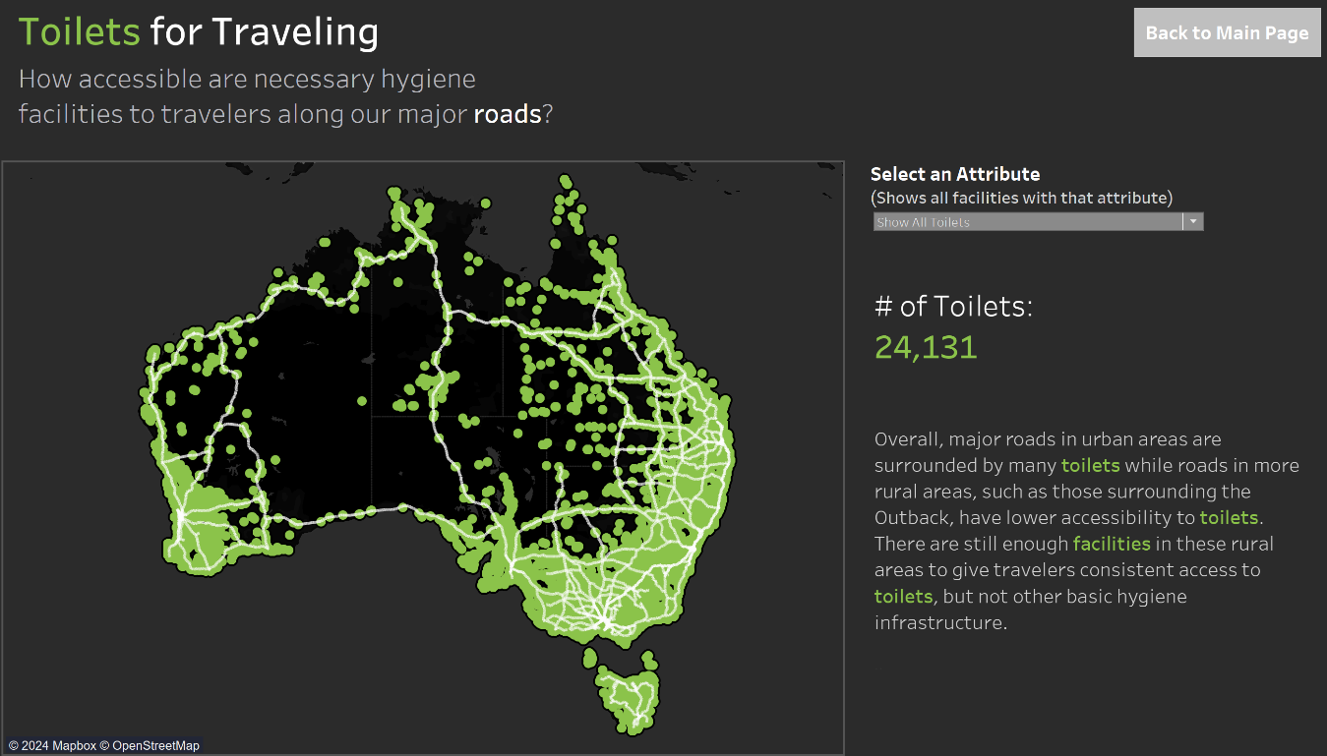

Note. This figure depicts all the locations of toilets in Australia layered on the national roads.

### **Figure A2**

*Toilets with Showers*

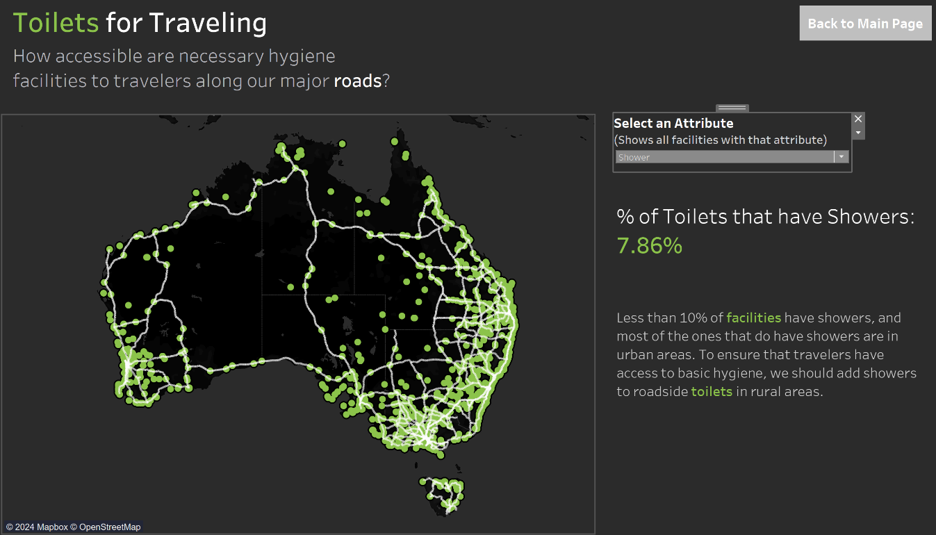

Note. This figure depicts the locations of toilets with showers

### **Figure A3**

*Toilets with Parking*

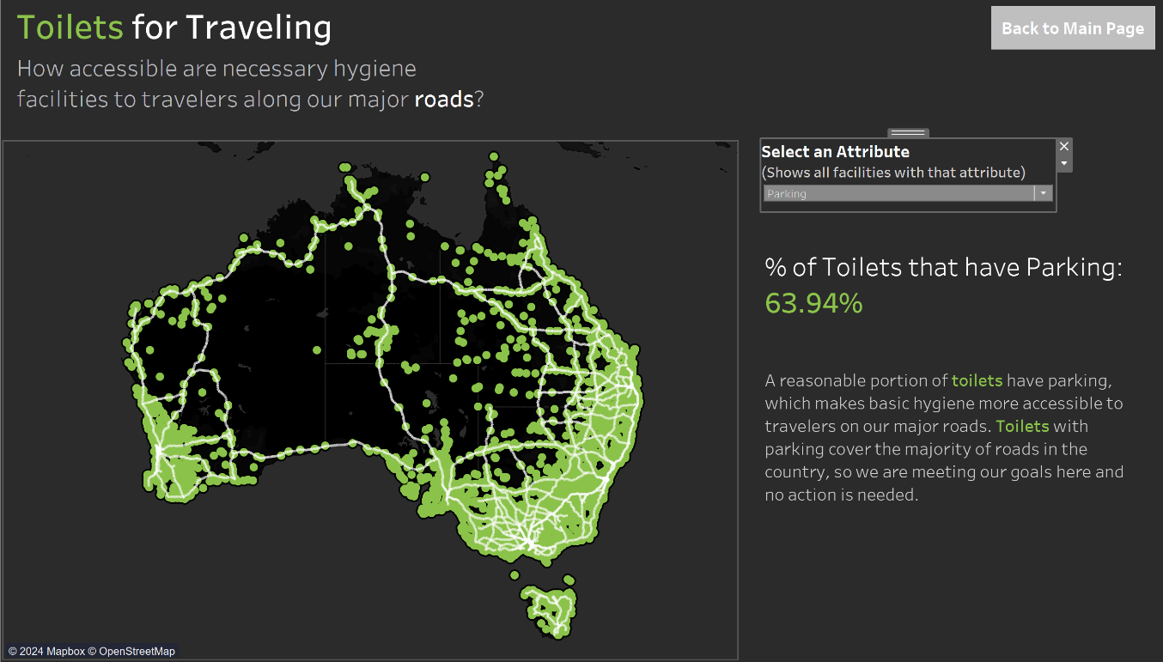

Note. This figure depicts the location of toilets with parking

### **Figure A4**

*Toilets with Dump Points*

Note. This figure depicts the location of toilets with dump points

## **Accessible Toilets**

### **Figure B1**

*Which Facilities Have Accessible Toilets?*

Note. This figure demonstrates facilities which have Accessible Toilets

### **Figure B2**

*Which Facilities Have Accessible Parking?*

Note. This figure demonstrates facilities which have Accessible Parking

### **Figure B3**

*Which Facilities Have Ambulant Toilets?*

Note. This figure demonstrates facilities which have Ambulant Toilets

### **Figure B4**

*Which Facilities Have On-Site Slings?*

Note. This figure demonstrates facilities which have On-Site Slings

### **Figure B5**

*Which Facilities Have Adult Changing Rooms?*

Note. This figure demonstrates facilities which have Adult Changing Rooms

### **Figure B6**

*Which Facilities Have Changing Places Certification?*

Note. This figure demonstrates facilities which have Changing Places Certification

### **Figure B7**

*Which Facilities Have Left-Handed Rails?*

Note. This figure demonstrates facilities which have Left-Handed Rails

### **Figure B8**

*Which Facilities Have Right-Handed Rails?*

Note. This figure demonstrates facilities which have Right-Handed Rails

## **Toilets and Public Health**

### **Figure C1**

*Toilets vs Kidney Disease by Town*

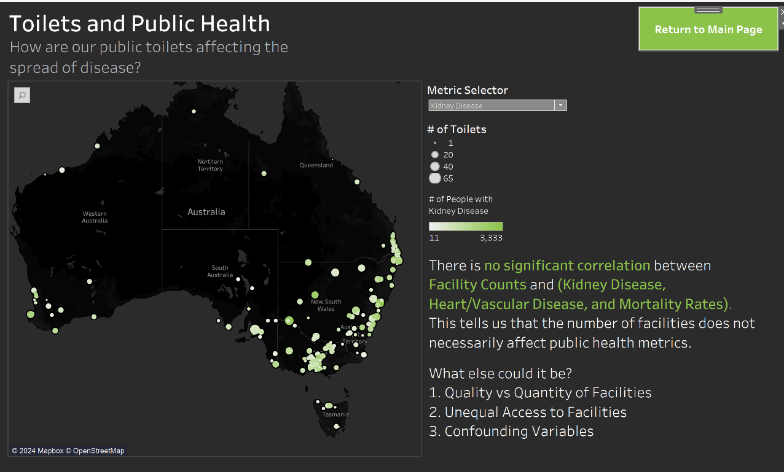

Note. This figure demonstrates the number of Toilets (Size of Dot) and number of people with Kidney Disease (Shade of Green of Dot). Each Dot is a Town.

### **Figure C2**

*Toilets vs Heart/Vascular Disease by Town*

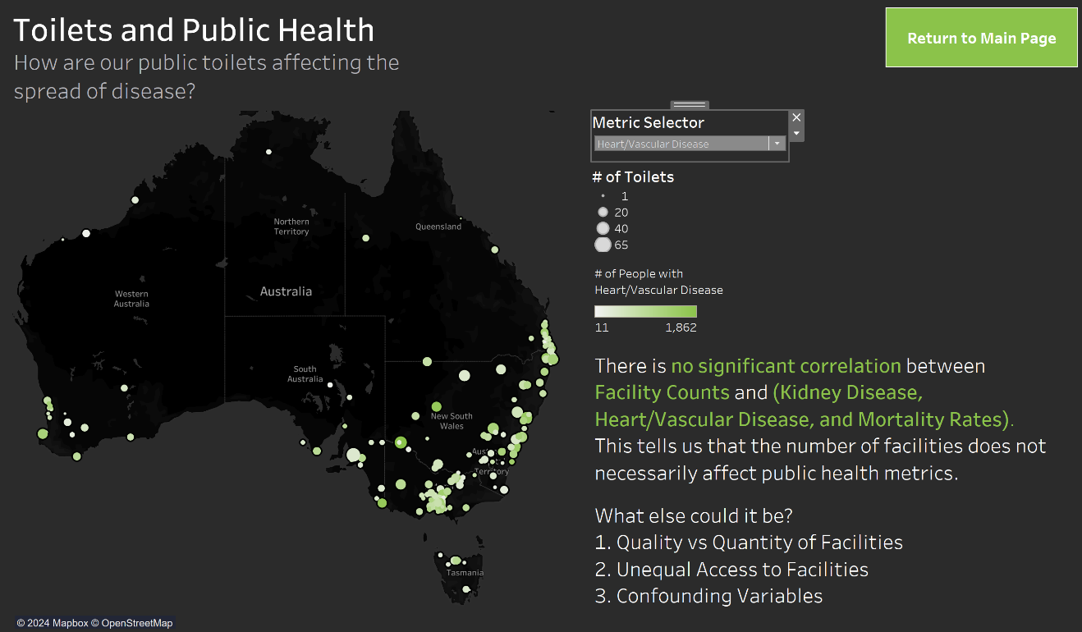

Note. This figure demonstrates the number of Toilets (Size of Dot) and number of people with Heart/Vascular Disease (Shade of Green of Dot). Each Dot is a Town.

### **Figure C3**

*Toilets vs Number of Mortalities by Town*

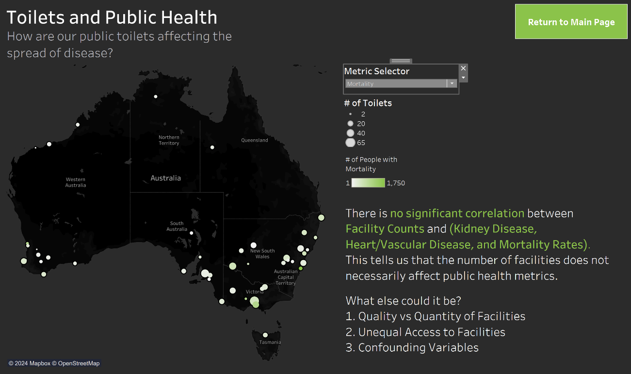

Note. This figure demonstrates the number of Toilets (Size of Dot) and number of Mortalities (Shade of Green of Dot). Each Dot is a Town.

### **Figure C4**

*Toilets vs all Public Health Metrics*

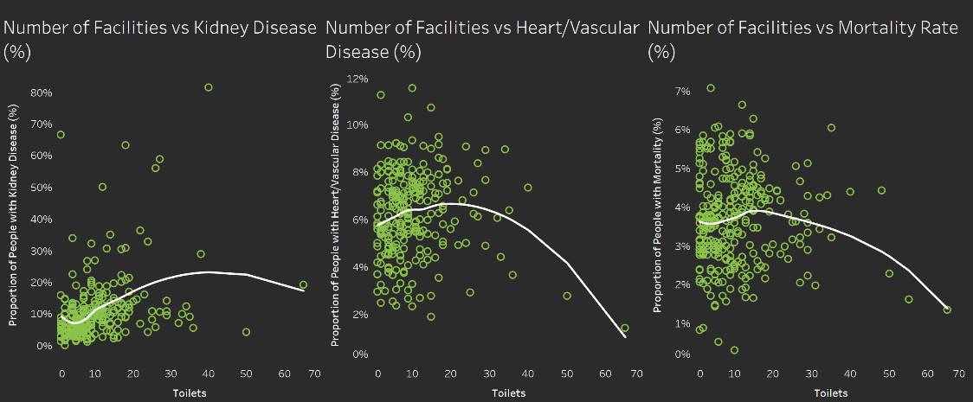

Note. This figure demonstrates the number of Toilets vs Public Health Metrics. Trend line used is a LOESS Model

## **Toilets and Pollution**

### **Figure D1**

*Toilets Across Australia*

Note. This figure demonstrates the locations of toilets across Australia by latitude and longitude.

### **Figure D2**

*Air Pollution Across Australia*

Note. This figure demonstrates air emissions across Australia, with larger circles indicating higher emissions.

### **Figure D3**

*Water Pollution Across Australia*

Note. This figure demonstrates water pollution across Australia, with larger circles indicating higher pollution.

### **Figure D4**

*Land Pollution Across Australia*

Note. This figure demonstrates land emissions across Australia, with larger circles indicating higher emissions.

### **Figure D5**

*Australian Toilet Locations by State*

Note. This figure demonstrates toilet locations by state across Australia, with higher bars showing more toilets.

### **Figure D6**

*Air Pollution by State across Australia*

Note. This figure demonstrates air emissions across Australia, with higher bars indicating more emissions.

### **Figure D7**

*Water Pollution by State Across Australia*

Note. This figure demonstrates water emissions across Australia, with higher bars indicating more emissions.

### **Figure D8**

*Land Pollution by State Across Australia*

Note. This figure demonstrates land emissions across Australia, with higher bars indicating more emissions.

### **Figure D9**

*Correlation Coefficient Calculation*

Note. This figure calculates correlation based on the type of pollution and the number of toilets in the location.

## **Gendered Toilets**

### **Figure E1**

*Gendered Toilet Counts by State*

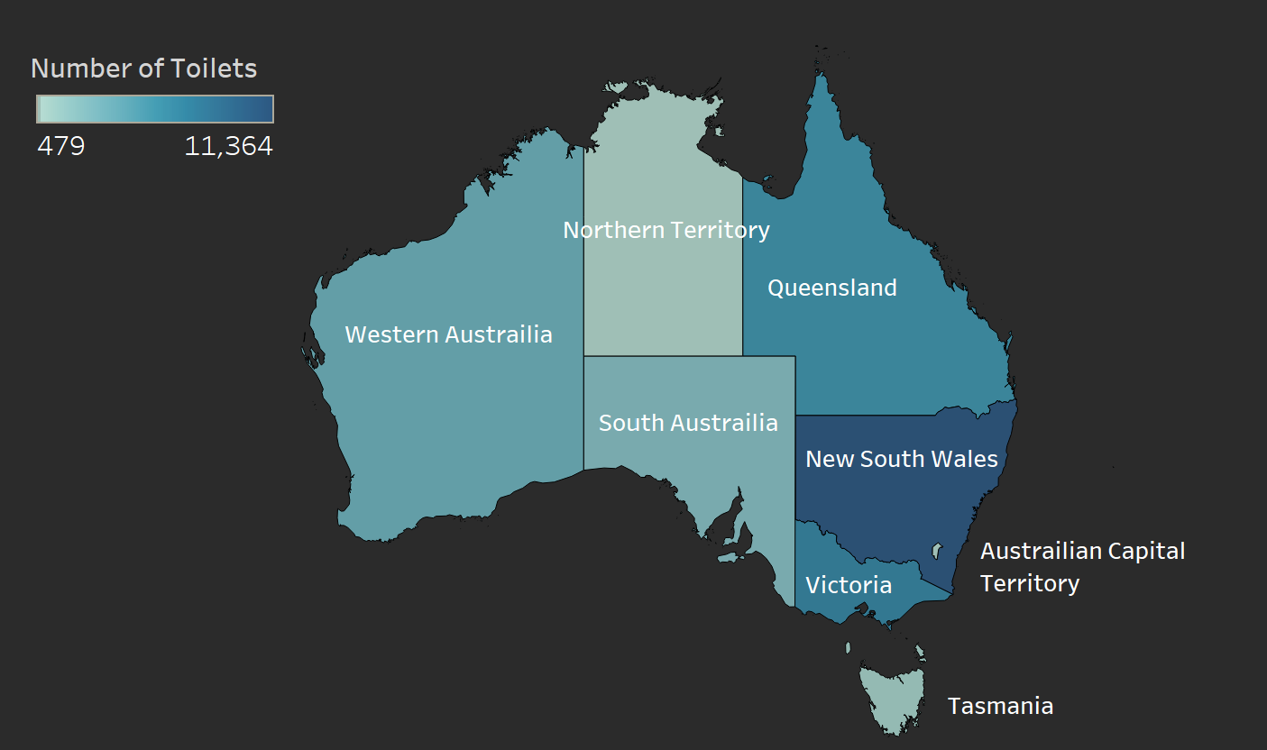

Note. This figure demonstrates the counts of gendered toilet types (Male and Female combined) by state and is changed using a parameter.

### **Figure E2**

*Unisex Toilet Counts by State*

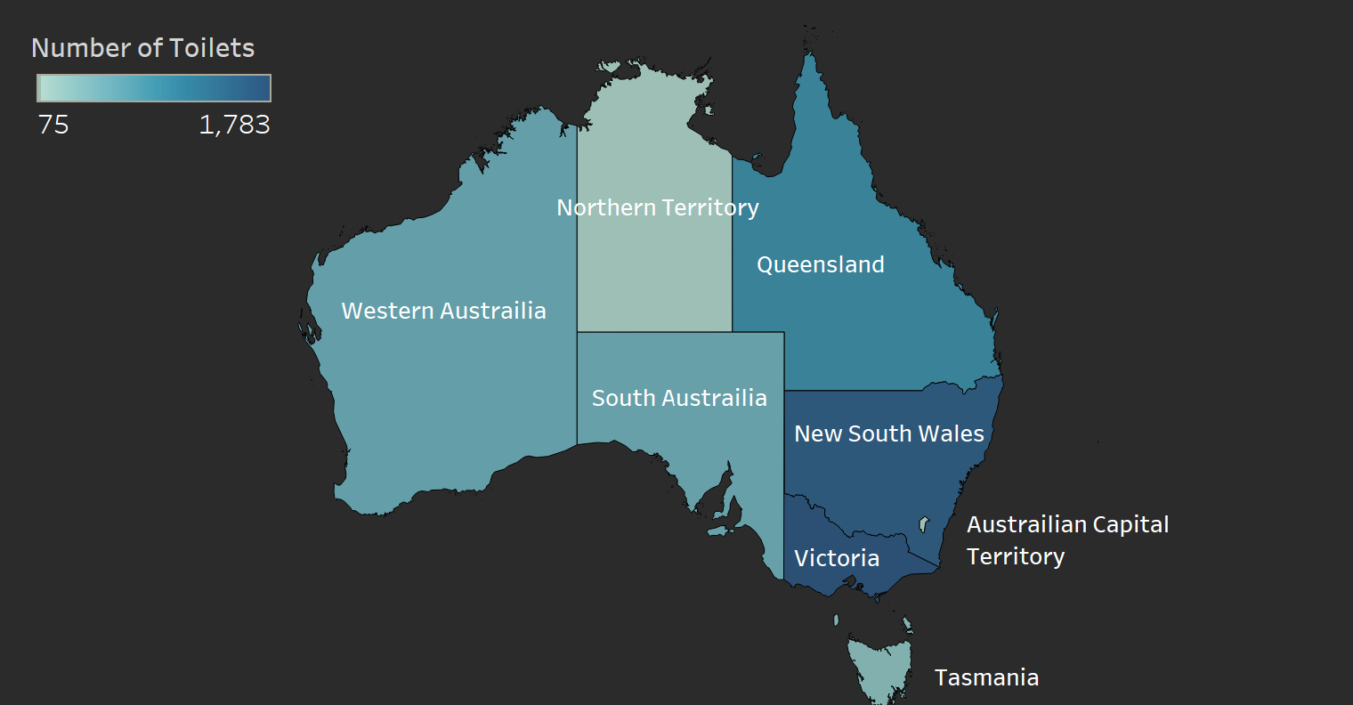

Note. This figure demonstrates the counts of unisex toilet types (No gender discrimination) by state and is changed using a parameter.

### **Figure E3**

*Gendered Toilets by State (Bar)*

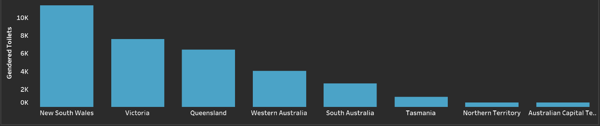

Note. This figure demonstrates the difference in the amounts of gendered toilets across states. This bar can be changed by a parameter

### **Figure E4**

*Unisex Toilets by State (Bar)*

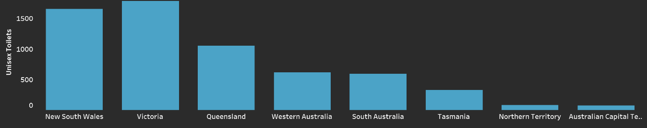

Note. This figure demonstrates the difference in the amounts of unisex toilets across states. This bar can be changed by a parameter.

# **Documentation**

## **Division of Visualization Responsibility**

* ***Ethan Ericson*** was responsible for the landing page and the Toilets for Traveling redirect.
* ***Jaxon Ham*** was responsible for the Accessible Toilets redirect.
* ***Andrew Mendez*** was responsible for the R integration and the Toilets and Public Health redirect.
* ***Medhansh Sankaran*** was responsible for the Toilets and Pollution redirect.
* ***Ethan Styles*** was responsible for the Gendered Toilets redirect.

## **Toilets for Traveling Redirect Documentation**

### ***Parameter 1***

|  |  |  |  |
| --- | --- | --- | --- |
| **Parameter Name** | **Input Type** | **Where it is used** | **Purpose of the Parameter** |
| Select Attribute | List of String | Toilets by Highways (Ericson) | Select what travel – related attribute the graph will be filtered based on |

### ***Calculated Field 1***

|  |  |  |  |
| --- | --- | --- | --- |
| **Name of Field** | **Formula** | **Where it is used** | **Purpose of the field** |
| Attribute Filter | CASE [Select Attribute]  WHEN "Show All Toilets" THEN True  WHEN "Parking" THEN [Parking] = True  WHEN "Shower" THEN [Shower] = TRUE  WHEN "Dump Point" THEN [Dump Point] = TRUE  END | Toilets by Highways (Ericson) | Filter toilets by the selected travel – related attribute. |

### ***Calculated Field 2***

|  |  |  |  |
| --- | --- | --- | --- |
| **Name of Field** | **Formula** | **Where it is used** | **Purpose of the field** |
| Toilet Proportion Text | CASE [Select Attribute]  WHEN "Show All Toilets" THEN "# of Toilets: "  WHEN "Parking" THEN "% of Toilets that have Parking:"  WHEN "Shower" THEN "% of Toilets that have Showers:"  WHEN "Dump Point" THEN "% of Toilets that have a Dump Point:"  END | Attribute Proportion Text(Ericson) | Set up dynamic text for proportion of toilets with selected attributes out of total toilets |

### ***Calculated Field 3***

|  |  |  |  |
| --- | --- | --- | --- |
| **Name of Field** | **Formula** | **Where it is used** | **Purpose of the field** |
| Toilet Proportion Sign | CASE [Select Attribute]  WHEN "Show All Toilets" THEN ""  WHEN "Parking" THEN "%"  WHEN "Shower" THEN "%"  WHEN "Dump Point" THEN "%"  END | Attribute Proportion Text(Ericson) | Set up dynamic sign that accompanies proportion text |

### ***Calculated Field 4***

|  |  |  |  |
| --- | --- | --- | --- |
| **Name of Field** | **Formula** | **Where it is used** | **Purpose of the field** |
| Toilet Proportions | CASE [Select Attribute]  WHEN "Show All Toilets"  THEN SUM({ FIXED : COUNT([Facility ID]) })  WHEN "Parking"  THEN ROUND(SUM(IF [Parking] THEN 1 ELSE 0 END) /  SUM({ FIXED : COUNT([Facility ID]) }) * 100, 2)  WHEN "Shower"  THEN ROUND(SUM(IF [Shower] THEN 1 ELSE 0 END) /  SUM({ FIXED : COUNT([Facility ID]) }) * 100, 2)  WHEN "Dump Point"  THEN ROUND(SUM(IF [Dump Point] THEN 1 ELSE 0 END) /  SUM({ FIXED : COUNT([Facility ID]) }) * 100, 2)  END | Attribute Proportion Text(Ericson) | Calculate the dynamic proportions that accompany the proportion text |

### ***Calculated Field 5 (Grouped)***

|  |  |  |  |
| --- | --- | --- | --- |
| **Name of Field** | **Formula** | **Where it is used** | **Purpose of the field** |
| Explanation [1st-7th] Part | CASE [Select Attribute]  WHEN "Show All Toilets"  THEN "[Text between keywords for all toilets explanation]"  WHEN "Parking"  THEN "[Text between keywords for parking explanation]"  WHEN "Shower"  THEN "[Text between keywords for shower explanation]"  WHEN "Dump Point"  THEN "[Text between keywords for dump point explanation]"  END | Text Explanation (Ericson) | Generate the unhighlighted explanation text that changes dynamically based on the selected parameter |

### ***Calculated Field 6 (Grouped)***

|  |  |  |  |
| --- | --- | --- | --- |
| **Name of Field** | **Formula** | **Where it is used** | **Purpose of the field** |
| Key words [1st-6th] Part | CASE [Select Attribute]  WHEN "Show All Toilets"  THEN "[keyword]"  WHEN "Parking"  THEN "[keyword]"  WHEN "Shower"  THEN "[keyword]"  WHEN "Dump Point"  THEN "[keyword]"  END | Text Explanation (Ericson) | Highlight important parts of the dynamic text explanation. |

## **Accessible Toilets Redirect Documentation**

### **Parameters**

|  |  |  |  |
| --- | --- | --- | --- |
| **Parameter Name** | **Input Type** | **Where it is used** | **Purpose of the Parameter** |
| Accessibility Feature Selection | String | Feature Filter | To specify the Accessibility feature the user wants to investigate, also causes filter to change on maps and bar. |
| State | String | Map | To hide the null values of the Facilities, specifically where ‘State’ is null. |

### **Calculated Fields**

|  |  |  |  |
| --- | --- | --- | --- |
| **Name of Field** | **Formula** | **Where it is used** | **Purpose of the field** |
| Feature Filter | [Accessibility Feature Selection] = "Accessible Parking" and [Parking Accessible] = TRUE  OR [Accessibility Feature Selection] = "Adult Changing Room" and [Adult Change] = TRUE  OR [Accessibility Feature Selection] = "Changing Places Certification" and [Changing Places] = TRUE  OR [Accessibility Feature Selection] = "Ambulant Toilets" and [Ambulant] = TRUE  OR [Accessibility Feature Selection] = "Accessible Toilets" and [Accessible] = TRUE  OR [Accessibility Feature Selection] = "Left-Handed Rails" and [LH Transfer] = TRUE  OR [Accessibility Feature Selection] = "Right-Handed Rails" and [RH Transfer] = TRUE  OR [Accessibility Feature Selection] = "On-Site Sling" and [BYO Sling] = TRUE | Map and Bar Chart For Accessibility | To filter out Facilities that do not have the Accessibility feature specified in the Parameter |

## **Toilets and Public Health Redirect Documentation**

### ***Calculated field 1/R integration 1***

|  |  |  |  |
| --- | --- | --- | --- |
| **Name of Field** | **Code** | **Where it is used** | **Purpose of integration** |
| KD LOESS | SCRIPT_REAL(  "  df <- data.frame(ft=.arg1, ht=.arg2);  predict(loess(ft ~ ht, data=df))  ",  SUM([KD Proportion %]), COUNT([Facility ID])  ) | Number of Toilets vs Kidney Scatter plot | To show a better trend line of scatter plot |

### ***Calculated field 2/R integration 2***

|  |  |  |  |
| --- | --- | --- | --- |
| **Name of Field** | **Code** | **Where it is used** | **Purpose of integration** |
| HVD LOESS | SCRIPT_REAL(  "  df <- data.frame(ft=.arg1, ht=.arg2);  predict(loess(ft ~ ht, data=df))  ",  SUM([HVD Proportion %]), COUNT([Facility ID])  ) | Number of Toilets vs Heart/Vascular Disease Scatter plot | To show a better trend line of scatter plot |

### ***Calculated field 3/R integration 3***

|  |  |  |  |
| --- | --- | --- | --- |
| **Name of Field** | **Code** | **Where it is used** | **Purpose of integration** |
| Mort LOESS | SCRIPT_REAL(  "  df <- data.frame(ft=.arg1, ht=.arg2);  predict(loess(ft ~ ht, data=df))  ",  SUM([Mort Proportion %]), COUNT([Facility ID])  ) | Number of Toilets vs Mortality Rate scatter plot | To show a better trend line of scatter plot |

### ***Calculated field 4***

|  |  |  |  |
| --- | --- | --- | --- |
| **Name of Field** | **Formula** | **Where it is used** | **Purpose of the field** |
| KD Proportion % | 100*([Number (Kidney Disease)]/[Population (Kidney Disease)]) | Number of Toilets vs Kidney Disease scatter plot and R integrations | All the prop % columns had invalid numerical data so I had to recalculate it to make it valid numerical data |

### ***Calculated field 5***

|  |  |  |  |
| --- | --- | --- | --- |
| **Name of Field** | **Formula** | **Where it is used** | **Purpose of the field** |
| HVD Proportion % | 100*([Number (HVD)]/[Population (HeartVVascular Disease)]) | Number of Toilets vs Heart/Vascular disease scatter plot and R integrations | All the prop % columns had invalid numerical data so I had to recalculate it to make it valid numerical data |

### ***Calculated field 6***

|  |  |  |  |
| --- | --- | --- | --- |
| **Name of Field** | **Formula** | **Where it is used** | **Purpose of the field** |
| Mort Proportion % | 100*([Total deaths]/[Population (Mortality Rates)]) | Number of Toilets vs Mortality scatter plot and R integrations | All the prop % columns had invalid numerical data so I had to recalculate it to make it valid numerical data |

### ***Calculated field 7***

|  |  |  |  |
| --- | --- | --- | --- |
| **Name of Field** | **Formula** | **Where it is used** | **Purpose of the field** |
| Chosen Metric | CASE [Metric Selector]  WHEN "Kidney Disease" THEN SUM([Number (Kidney Disease)])  WHEN "Heart/Vascular Disease" THEN SUM([Number (HVD)])  WHEN "Mortality" THEN SUM([Total deaths])  ELSE 0  END | On the Map for all public health metrics, Facilities counts, and towns | Based of the Metric Selector parameter you can change what public health metric your observing |

### ***Calculated field 8***

|  |  |  |  |
| --- | --- | --- | --- |
| **Name of Field** | **Formula** | **Where it is used** | **Purpose of the field** |
| Territory Filter | IF [By Territory ] = "All" THEN TRUE  ELSE [State] = [By Territory ]  END | Not used, ended up breaking the LOESS | Based of the By Territory parameter you can change what territory your looking at |

### ***Calculated field 9***

|  |  |  |  |
| --- | --- | --- | --- |
| **Name of Field** | **Formula** | **Where it is used** | **Purpose of the field** |
| Filter Mortality | IF [Metric Selector] = "Mortality" THEN [Year] = 2021  ELSE TRUE  END | On the Map for all public health metrics, Facilities counts, and towns | If mortality metric is selected. It gets rid of redundant towns that have no mortality data |

### ***Parameter 1***

|  |  |  |  |
| --- | --- | --- | --- |
| **Parameter Name** | **Input Type** | **Where it is used** | **Purpose of the Parameter** |
| Metric Selector | String | On the Map for all public health metrics, Facilities counts, and towns | To switch between what public health metric is being observed on the map |

### ***Parameter 2***

|  |  |  |  |
| --- | --- | --- | --- |
| **Parameter Name** | **Input Type** | **Where it is used** | **Purpose of the Parameter** |
| By Territory | String |  | To switch between what data/postion on the map your looking at by territory |

## **Toilets and Pollution Redirect Documentation**

### ***Calculated field 1***

|  |  |  |  |
| --- | --- | --- | --- |
| **Name of Field** | **Code** | **Where it is used** | **Purpose of integration** |
| Chosen Pollution | CASE [Choose Pollution Type]  WHEN 'Air Pollution' THEN [Air Total Emission Kg]  WHEN 'Water Pollution' THEN [Water Emission Kg]  WHEN 'Land Pollution' THEN [Land Emission Kg]  END | On the Parameter Choose Pollution Type | To integrate the pollution options between graphs. |

### ***Calculated field 2***

|  |  |  |  |
| --- | --- | --- | --- |
| **Name of Field** | **Code** | **Where it is used** | **Purpose of integration** |
| Correlation Calc | WINDOW_CORR(AVG([Chosen Pollution]), COUNT([Facility ID])) | Chosen Pollution type and Facility ID (unique toilets) | Calculates correlation between pollution and toilets |

### ***Calculated field 3***

|  |  |  |  |
| --- | --- | --- | --- |
| **Name of Field** | **Code** | **Where it is used** | **Purpose of integration** |
| Chosen Color | CASE [Choose Pollution Type]  WHEN 'Air Pollution' THEN 'Yellow'  WHEN 'Water Pollution' THEN 'Blue'  WHEN 'Land Pollution' THEN 'Green'  END | On the parameter Choose Pollution Type | To color code pollution types automatically without manual changing. |

### ***Calculated field 4***

|  |  |  |  |
| --- | --- | --- | --- |
| **Name of Field** | **Formula** | **Where it is used** | **Purpose of the field** |
| TextChooserAir | IF [Choose Pollution Type] = 'Air Pollution' THEN TRUE  ELSE FALSE  END | On the parameter Choose Pollution Type | Allows text to dynamically change on a dashboard when parameter options are selected |

### ***Calculated field 5***

|  |  |  |  |
| --- | --- | --- | --- |
| **Name of Field** | **Formula** | **Where it is used** | **Purpose of the field** |
| Merged State | IF ISNULL([State]) THEN [State1] ELSE [State] END | On the State identification field in both datasets | Merge both states together in order to perform easy filtering on both data |

### ***Parameter 1***

|  |  |  |  |
| --- | --- | --- | --- |
| **Parameter Name** | **Input Type** | **Where it is used** | **Purpose of the Parameter** |
| Choose Pollution Type | String | On the map for pollution and the bar chart for pollution | To switch between the pollution type (Air, Water, Land) viewed on the dashboard |

## **Gendered Toilets Documentation**

### ***Calculated Field 1***

|  |  |  |  |
| --- | --- | --- | --- |
| **Name of Field** | **Formula** | **Where it is used** | **Purpose of the field** |
| Male Toilets | SUM(IF [Male] THEN 1 ELSE 0 END) | The Map and the bar charts | Converts the true false into integer values for counts |

### ***Calculated Field 2***

|  |  |  |  |
| --- | --- | --- | --- |
| **Name of Field** | **Formula** | **Where it is used** | **Purpose of the field** |
| Female Toilets | SUM(IF [Female] THEN 1 ELSE 0 END) | The Map and the bar charts | Converts the true false into integer values for counts |

### ***Calculated Field 3***

|  |  |  |  |
| --- | --- | --- | --- |
| **Name of Field** | **Formula** | **Where it is used** | **Purpose of the field** |
| Gendered Toilets | [Male Toilets] + [Female Toilets] | The Map and the bar charts | Adds up male and female toilets |

### ***Calculated Field 4***

|  |  |  |  |
| --- | --- | --- | --- |
| **Name of Field** | **Formula** | **Where it is used** | **Purpose of the field** |
| Unisex Toilets | SUM(IF [Unisex] THEN 1 ELSE 0 END) | The Map and the bar charts | Converts the true false into integer values for counts |

### ***Calculated Field 5***

|  |  |  |  |
| --- | --- | --- | --- |
| **Name of Field** | **Formula** | **Where it is used** | **Purpose of the field** |
| Toilet Totals | [Male Toilets] + [Female Toilets] + [Unisex Toilets] | Wasn’t used | Totals up all the previous calculated fields to get an overall total |

### ***Calculated Field 6***

|  |  |  |  |
| --- | --- | --- | --- |
| **Name of Field** | **Formula** | **Where it is used** | **Purpose of the field** |
| Toilet Types | IF [Male] THEN "Male"  ELSEIF [Female] THEN "Female"  ELSEIF [Unisex] THEN "Unisex"  END | Wasn’t used | Was intended to separate toilet totals but failed |

### ***Calculated Field 7***

|  |  |  |  |
| --- | --- | --- | --- |
| **Name of Field** | **Formula** | **Where it is used** | **Purpose of the field** |
| Toilet Type Count | IF [Toilet Type Filter] = "Male Toilets" THEN [Male Toilets]  ELSEIF [Toilet Type Filter] = "Female Toilets" THEN [Female Toilets]  ELSEIF [Toilet Type Filter] = "Unisex Toilets" THEN [Unisex Toilets]  ELSEIF [Toilet Type Filter] = "Gendered Toilets" THEN [Gendered Toilets]  END | Map | Allows the parameter to change the way the map is colored |

### ***Calculated Field 8 – Added by Ericson to get map to work after importing***

|  |  |  |  |
| --- | --- | --- | --- |
| **Name of Field** | **Formula** | **Where it is used** | **Purpose of the field** |
| State (full) | CASE [State]  WHEN "NSW" THEN "New South Wales"  WHEN "VIC" THEN "Victoria"  WHEN "QLD" THEN "Queensland"  WHEN "SA" THEN "South Australia"  WHEN "WA" THEN "Western Australia"  WHEN "TAS" THEN "Tasmania"  WHEN "NT" THEN "Northern Territory"  WHEN "ACT" THEN "Australian Capital Territory"  ELSE [State]  END | Map | Shows the full name of the states |

### ***Parameter 1***

|  |  |  |  |
| --- | --- | --- | --- |
| **Parameter Name** | **Input Type** | **Where it is used** | **Purpose of the Parameter** |
| Toilet Type Filter | List of String | Map (Styles) | Select whether you want the map to display counts of Male, Female (those are actually the same), Gendered, or Unisex. |